**JENKINS TASK**

1. Install Jenkins and run Jenkins on port number 8081.

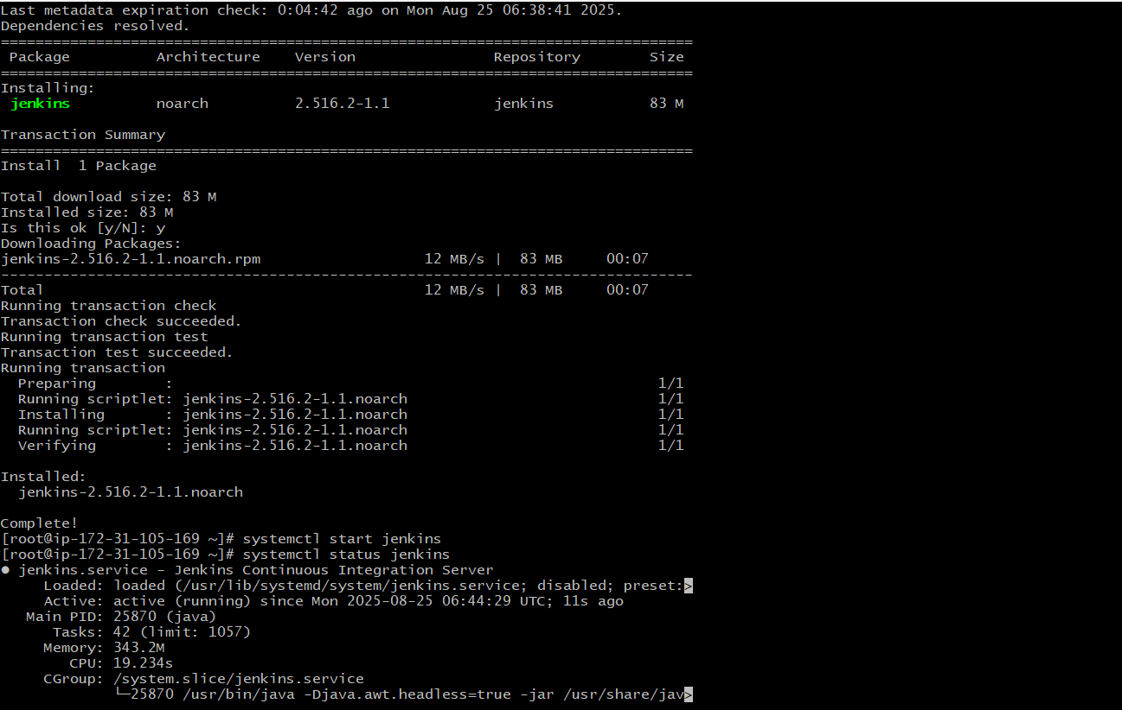

1. Secure Jenkins server

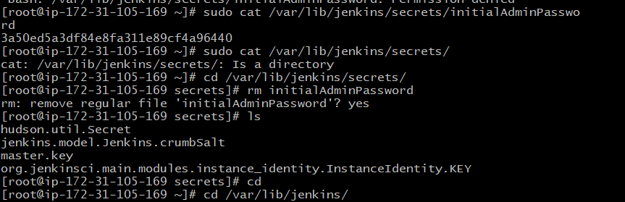

We have to remove that screct key from the PC and in Jenkins go to security and edit the password and change it. Then we can login we the edited password.

Now the Jenkins is Secure.

3) Create users called DevOps, Testing in Jenkins with Limited access.

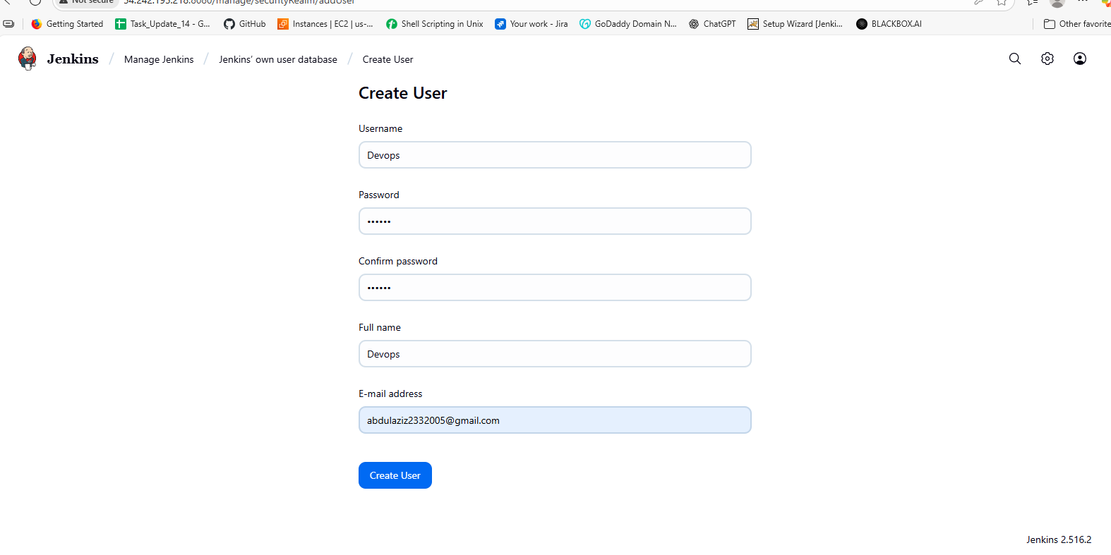

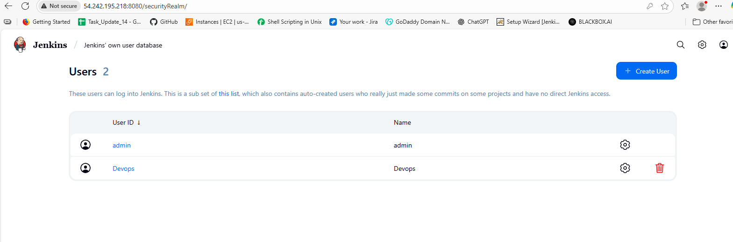

Then go to plugins and install role strategy in plugins.

Then go to manage and then security and then credentials.

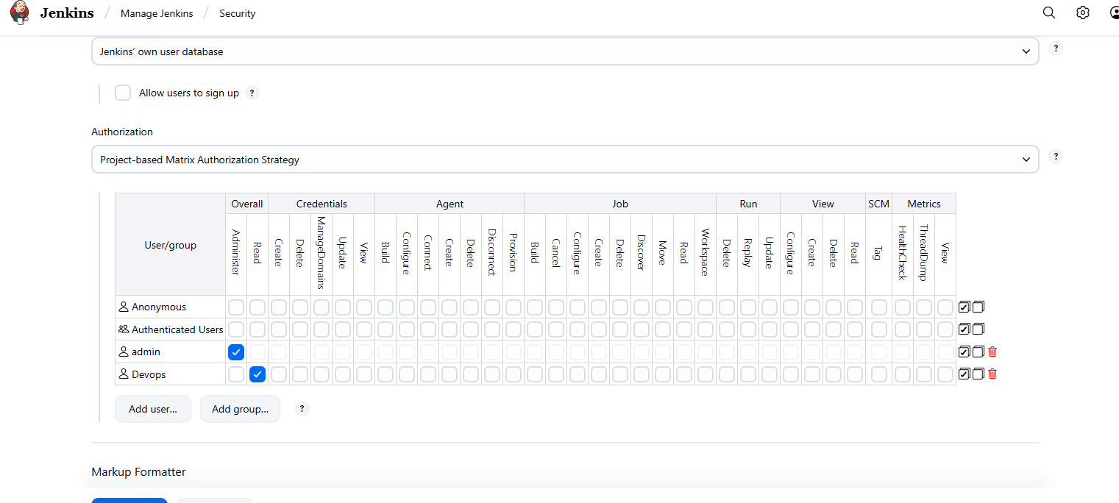

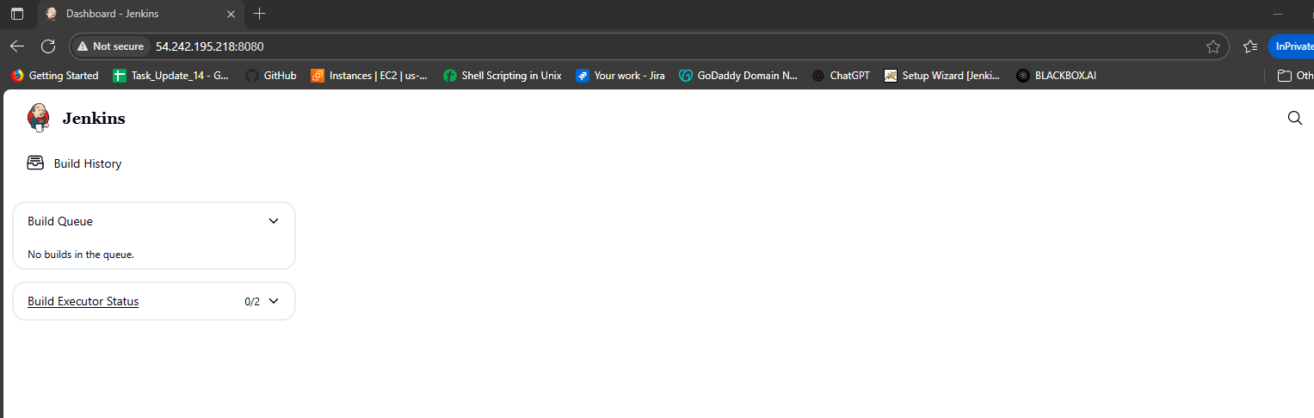

After creating the user we cant able to see the create job in this because we have given only the read access to this user.

1. Configure labels and restrict the jobs to execute based on label only.

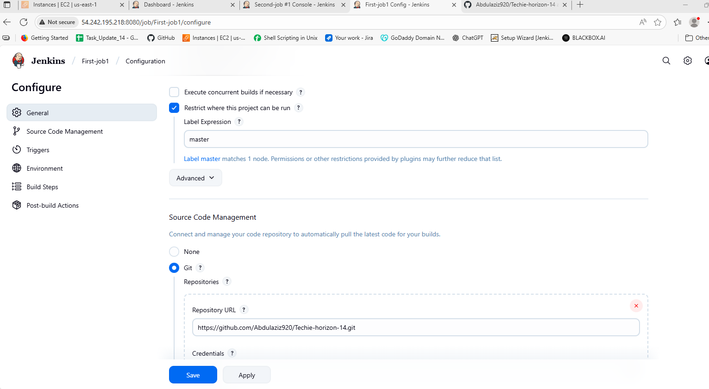

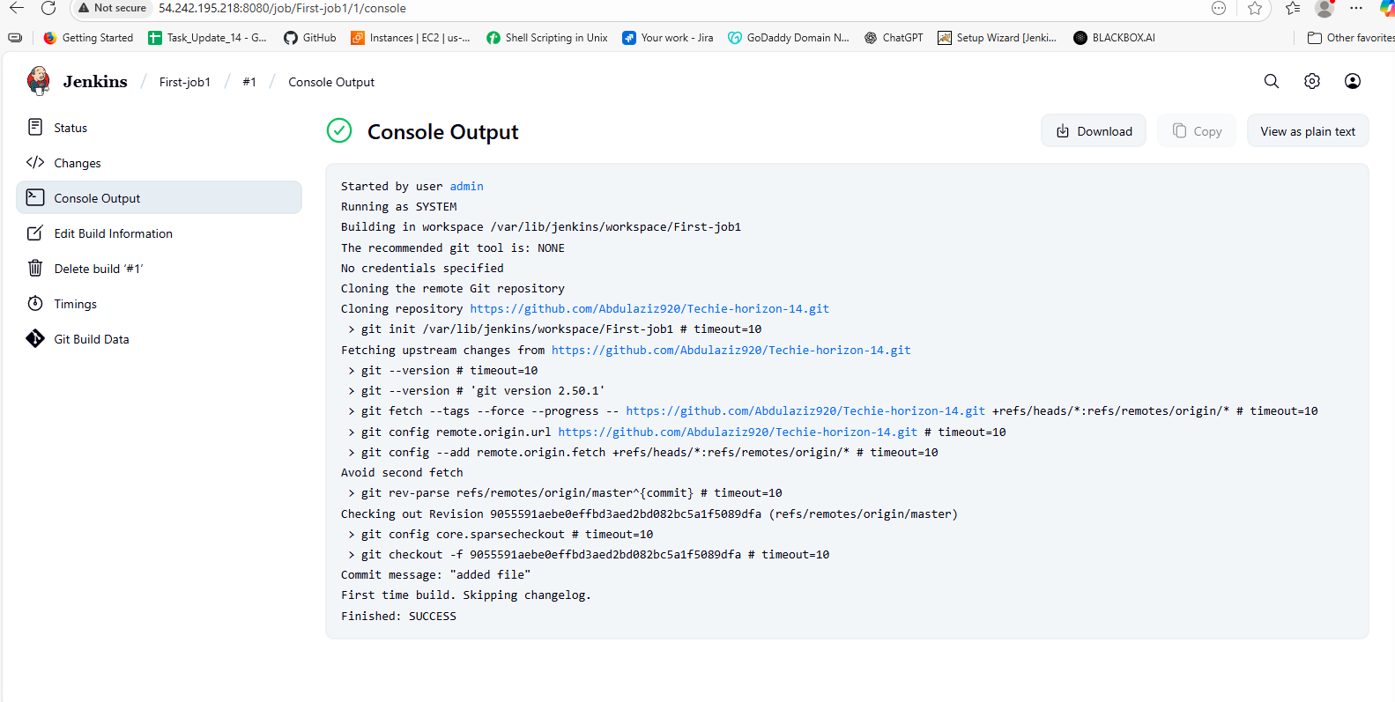

In the above job I have given the label and in one more job we don’t have to assign the label only have to attach the git repo url..

So the console output will be

5) Create Three sample jobs using the below URL.

<https://github.com/betawins/Techie_horizon_Login_app.git>

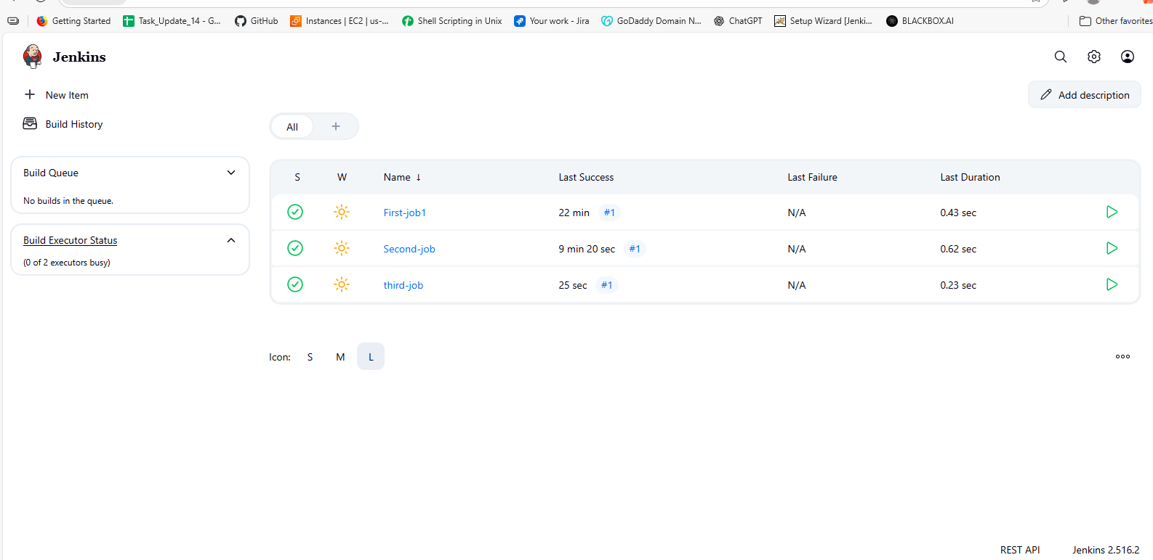

1. Create one Jenkins job using git hub Private repository.

